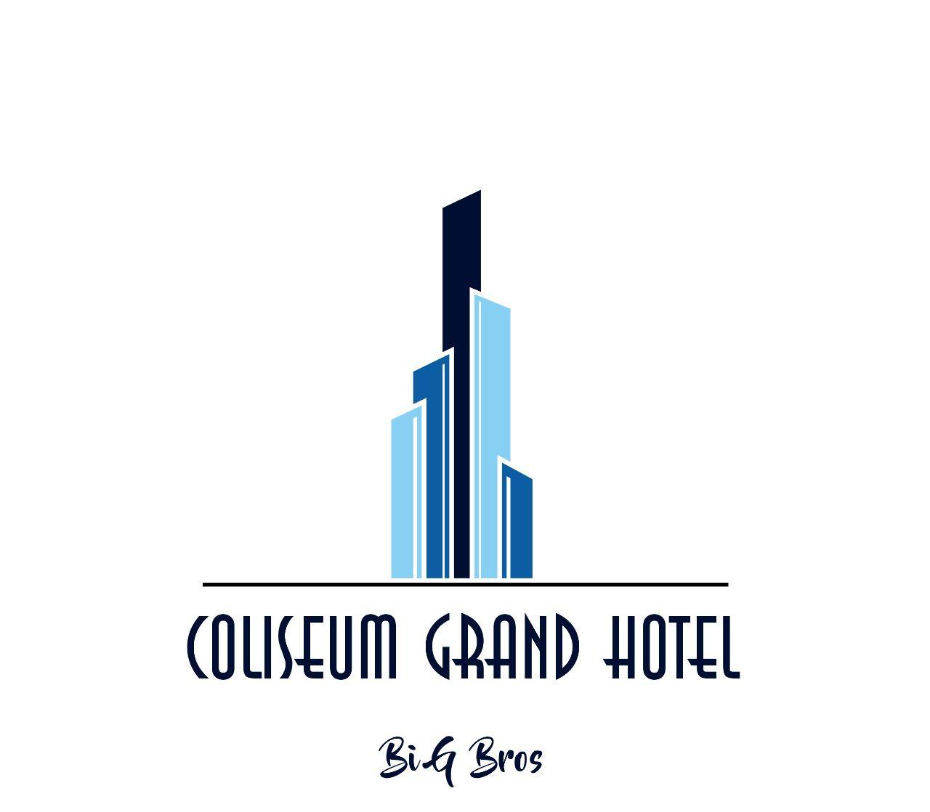

Members:

Asadbek Gaybullaev U1810166

Boburjon Akhmedov U1810186

Khumoyun Akramov U1810121

Jaloliddin Khujaniyozov U1810190

Raimov Shakhzod U1810174

Nurullaev Nasrullo U1810208

**https://github.com/iuthub/ip-group-project-big-bros**

We designed “Coliseum Grand” hotel web site, which enables you to familiarize with hotel services and can help to book online.

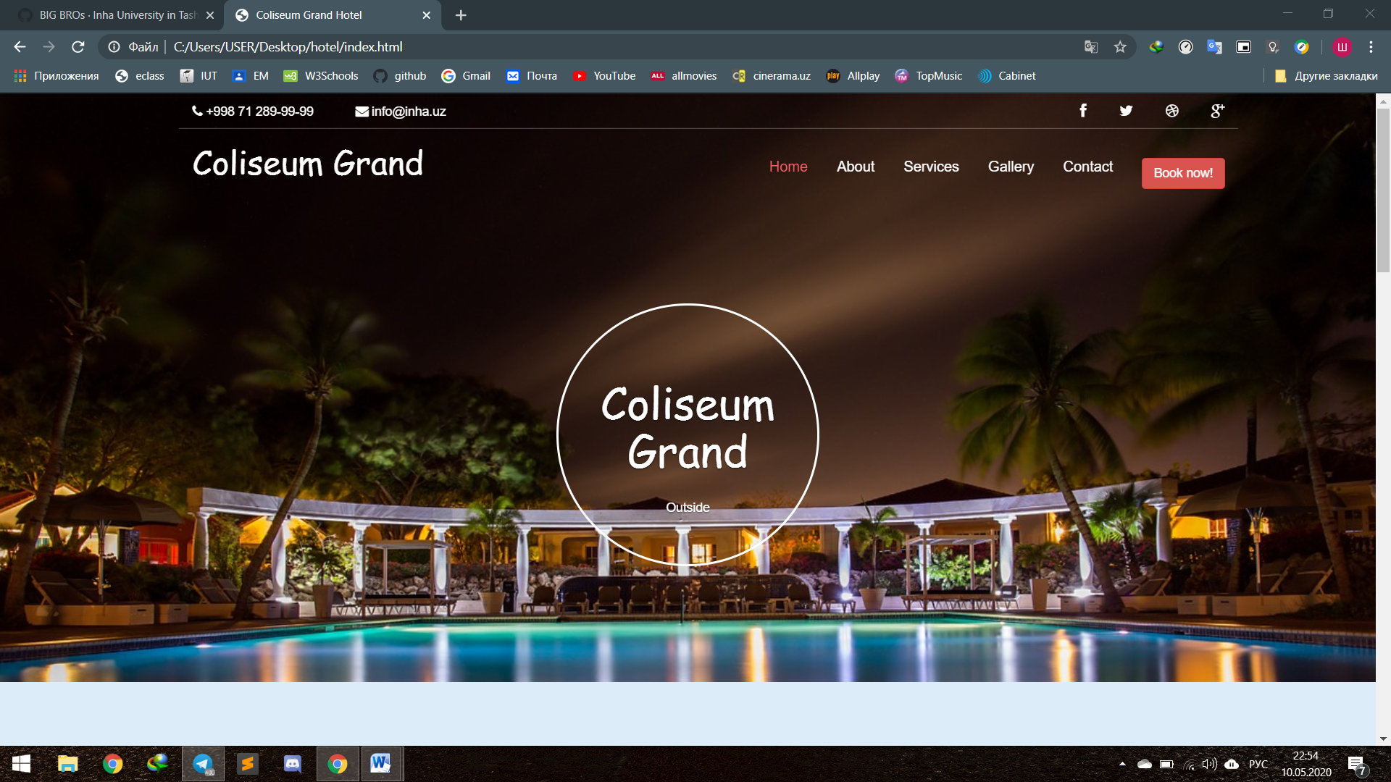

Coliseum Grand Hotel in Tashkent is a modern hotel with elegant restaurants and bars, luxuriously designed rooms and suites, that come together with combination of many services aimed at making your stay enjoyable. Rest in quite and comfortably furnished rooms, spend your free time with your friends or associates over drinks at our “Retro” Bar, taste the most delicious local and western meals prepared by our experience Chefs at our restaurant “Coliseum”, or work out at our fitness center under the supervision of a professional trainer.

Coliseum Grand has one of the best locations among Tashkent Hotels. The hotel is located in downtown of Tashkent, in the area with offices of many international organizations. 10-15 minutes drive separates the hotel from Tashkent International Airport and the Central Railway Stations.

